|  |  |
| --- | --- |
| **Test Name** | Crown & Anchor Automated Test Fix of Bug 3a |
| **Use Case Tested:** | Automate the testing of errors in UAT Test 3 (for Fix of Bug 3a – SPADE die roll not showing) |
| **Test Description:** | Test that the SPADE is rolled in the game |
| **Pre-conditions** | One game will run for 1,000 turns. |
| **Post-conditions** | n/a |
| **Notes:** | **An assert will be true if a SPADE is never rolled.** |
| **Result (Pass/Fail/Warning/Incomplete)** | **Fail: SPADES are now rolled, bug is fixed. See screenshot below (only last few rolls of the 1,000 are shown)** |

# Screenshot

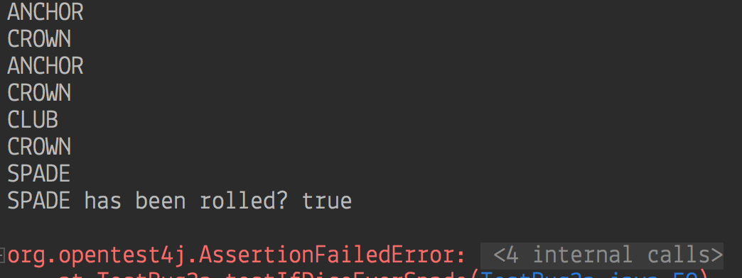

# Screenshots for Results (by number of result)

1) 200 turns played, ratio = 0.495 (50%):

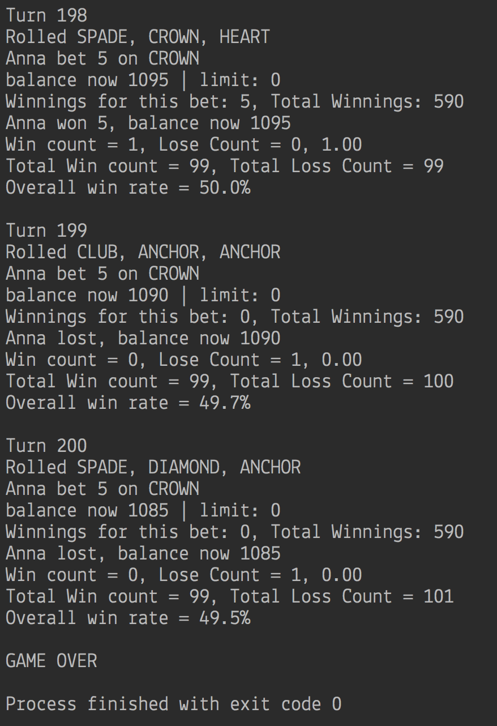

2) 200 turns played, ratio = 0.415 (42%):

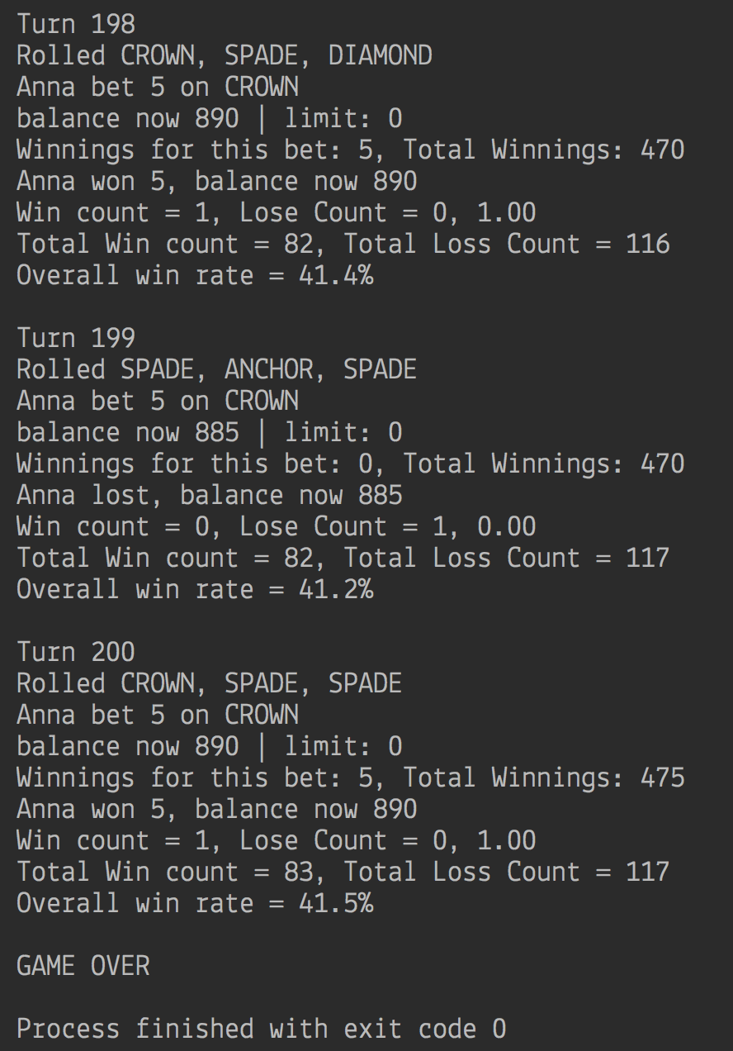

3) 200 turns played, ratio = 0.43 (43%):

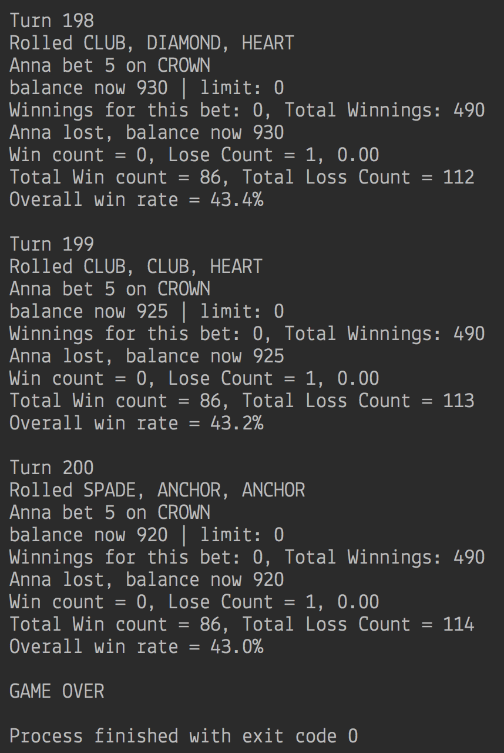

5) 1000 turns played, ratio = 0.417 (42%):

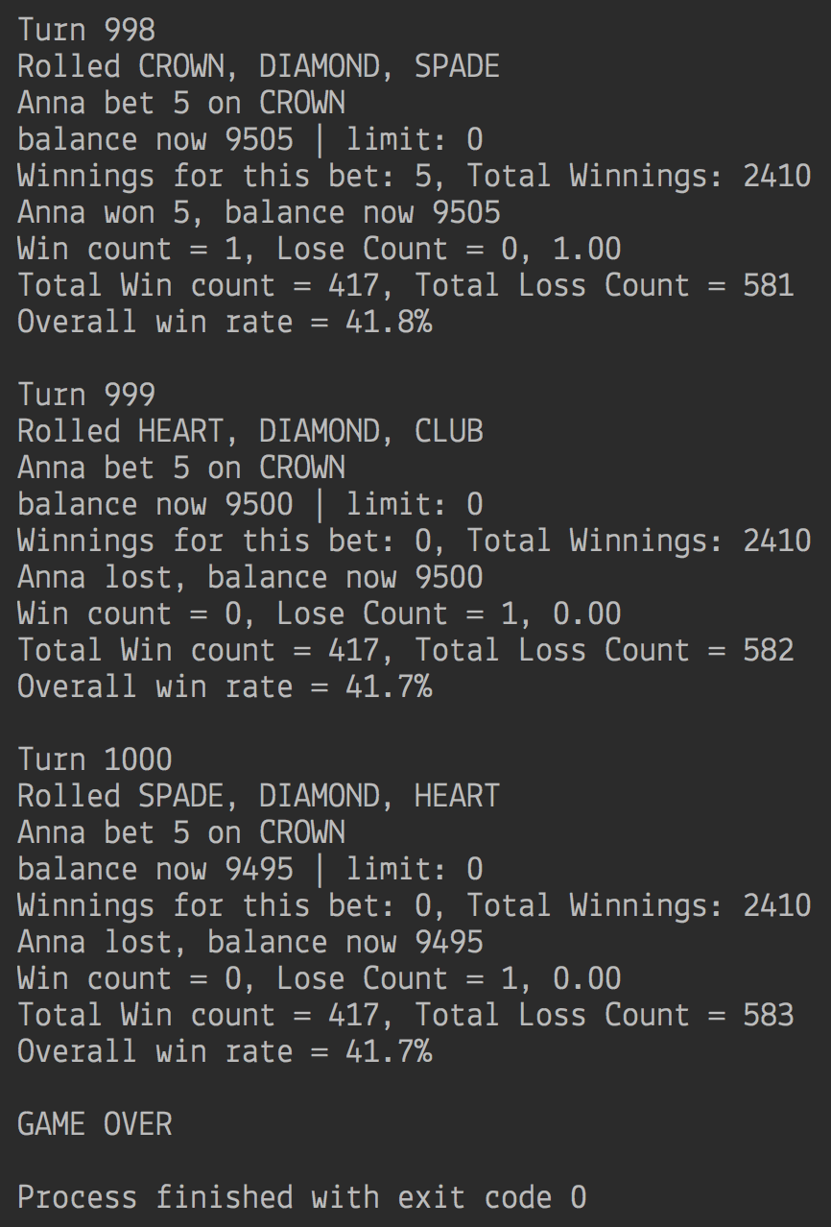

6) 50,000 turns played, ratio = (42%):

